Exercice 2

C1,3 Décoder, Exploiter les données techniques relatives à la réalisation d’une pièce  C21 Etablir un processus d'usinage | S2 Processus de fabrication  S214 Programmation des machines CN / Organisation d'un prog CN  S63 Langage de programmation
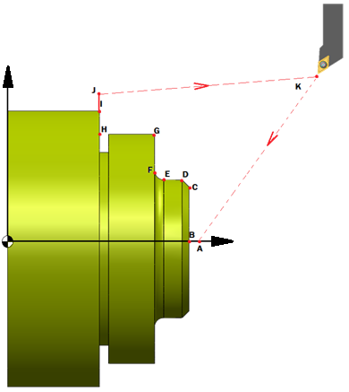
Sécurité de 5mm

POINTS | X | Z |  | R | Code G
A | 0 | 84 |  |  | G00
B | 0 | 79 |  |  | G01
C | 54 | 79 |  |  | G01
D | 60 | 76 |  |  | G01
E | 60 | 68 |  |  | G01
F | 68 | 64 |  | 4 | G02
G | 100 | 64 |  |  | G01
H | 100 | 40 |  |  | G01
I | 120 | 40 |  |  | G01
J | 130 | 40 |  |  | G01
K | 200 | 200 |  |  | G00
POINTS  BRUT | X |  | Z
1 | 130 |  |  | 40
2 | 130 |  |  | 84
3 | 0 |  |  | 84

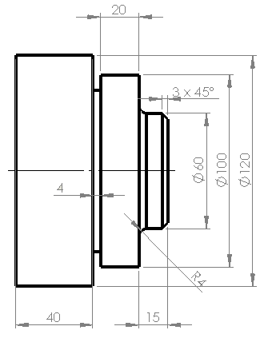

PROGRAMME |  |  | COMMENTAIRES
%2209
N10 G90 G40 G80 G95 M5 M9
N20 G0G52 X0
N30 G0 G52 Z0
N40 G54
N50 G79 N
N60 (PROFIL EXTERIEUR)
N70 G0 X0 Z84 |  | A
N80 G01 X0 Z79 F0.1 |  | B
N90 X54 Z79 |  | C
N100 X60 Z76 |  | D
N110 Z68 |  | E
N120 G02 X68 Z64 R4 |  | F
N130 G01 X100 Z64 |  | G
N140 Z40 |  | H
N150 X120 Z40 |  | I
N160 X130 |  | J
N170 (Ebauche extérieure)
N180 M6 T1 D1
N200 G92 S4000
N205 G97 S1000
N210 G0 X135 Z89 (point d’approche)
N220 G96 S100
N230 G64 N160 N70 I0.3 K 0.05 P2 F0.1
N240 X130 Z40 | 1 |  | Profil brut
N250 X130 Z84 | 2
N260 X0 Z84 | 3
N270 G80
N280 G77 N10 N40
N290 M6 T2 D2 M8
N300 G92 S4000 M3
N310 G97 S400
N320 G96 S150
N330 G77 G42 N70 N160 F0.05
N340 G77 N10 N40
N350 M30

